Assignment 1.

Student’s name
Institutional Affiliation
Instructor
Course code
Date of Submission

Cartoon 1.
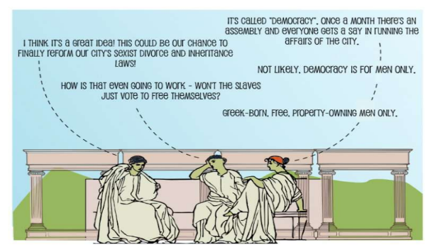
The modern-day nations, including the united states, have benefited entirely from the Greek invention of democracy. To some extent, the practice may be different in various because of changes in the modern world, but there are still apparent similarities that can be pointed out. Direct democracy allowed only a small group of men to vote. This was enough democracy to them and formed the basis for the policy of universal suffrage. Everybody in the United States, man or woman, is allowed to vote as long as they have reached the minimum age. Unlike in Athens, where they practiced direct democracy, in the united states, not every citizen vote regarding national issues but elected their representatives in the senate and house of representatives who deliberate in matters on behalf of citizens.

Cartoon 2.


Akhenaten made history when he opted to worship the polytheistic Egyptian gods introducing Atenism, which was monotheistic. This is considered the first step towards the worship of one God. Unlike the Egyptian religion, which involved worshiping different gods depending on the occasion and season of the year, Atenism involved worshiping only one god in all seasons. The common feature between the two religions is that both meant physical representation of the gods being worshiped. Atenism was centered on sun disc Aten while and later changed to the capital city, Amarna.

Cartoon 3.

Buddhism came to India at a time when the caste system had taken roots in ancient India. The class system regarded the poor as servants and slaves who were only supposed for the elite masters and rulers. The class system was considered permanent status that could not be changed as conditions of the servants were meant to remain the same to prevent upward movement on the social ladder. However, Buddhism taught against the permanence of the caste society and emphasized that the master would turn in to a slave as a slave to become a master in a new order. The founder of Buddhism was totally against the caste system in ancient India. Women were treated as less equal to opportunities than men, according to the society were supposed to be men's property.

References.
https://youtu.be/PobDpVqny3I
https://youtu.be/XnSo6Cwy_8M
https://youtu.be/dCdKg5DzMaQ
James, C. L. R. (1956). Every cook can govern: A study of democracy in ancient Greece: Its meaning for today. Brooklyn AGIT.

